CDC COVID-19 Response Update Report

DIRECTOR’S EXECUTIVE SUMMARY

Friday, July 22, 2022



**US Department of Health and Human Services**

**Centers for Disease Control and Prevention**

# COVID-19 Summary

|  |  |  |  |  |  |
| --- | --- | --- | --- | --- | --- |
|  | **Cumulative Total** | **Daily** | **7-Day Daily Average** | **Change from Prior**  **7-Day Period** | **Cumulative 7-Day Rate per 100K** |
| **Cases[1]** | 89,824,190 | 155,239 | 125,827 | +0.5% | 265.3 |
| **Hospital Admissions[2]** | 4,991,074 | 6,778 | 6,180 | +4.7% | 13.0 |
| **Deaths2** | 1,021,048 | 586 | 348 | -9.5% | 0.7 |
| **Test Volume[3]** | 925,534,224 | N/A | 553,132 | +4.0% | 1,002.7 |
| **Test Positivity3** | 9.3% | N/A | 17.3% | -1.7% | N/A |

Source: HHS Protect. Additional information available on [COVID Data Tracker](https://covid.cdc.gov/covid-data-tracker/#cases_casesper100klast7days) and in the [CDC COVID-19 Response Update](https://cdc.sharepoint.com/:f:/s/CPR-Responses/CovidMR/EmXuTs80CQtAgBQK81fzYJkBRwUOc1jgZ3YPa2L4vS6aiA?e=oiWyql)

# COVID-19 Vaccinations in the United States[4]

|  |  |  |  |  |
| --- | --- | --- | --- | --- |
| **Over 261.2 million people or 78.7% of the population have received at least 1 dose.** | | | | |
| **Age Group** | **Received at Least 1 Dose** | **Fully Vaccinated** | **Received 1st Booster / Additional Dose** | **Received 2nd Booster / Additional Dose[5]** |
| **US Overall** | 78.7% (N = 261,204,035) | 67.2% (N = 222,950,194) | 32.4% (N = 107,468,726) | 6.1% (N = 20,174,879) |
| **<5 Years of Age** | 2.8% (N = 544,054) | 0.0% (N = 3,638) | N/A | N/A |
| **5-11 Years of Age** | 37.1% (N = 10,651,590) | 30.2% (N = 8,672,809) | 2.8% (N = 795,754) | N/A |
| **12-17 Years of Age** | 70.2% (N = 17,773,621) | 60.2% (N = 15,221,693) | 16.7% (N = 4,230,179) | N/A |
| **≥5 Years of Age** | 83.4% (N = 260,497,603) | 71.4% (N = 222,866,449) | 34.4% (N = 107,348,428) | N/A |
| **≥12 Years of Age** | 88.1% (N = 249,846,013) | 75.5% (N = 214,193,640) | 37.6% (N = 106,552,674) | 6.7% (N = 20,171,798) |
| **≥18 Years of Age** | 89.9% (N = 232,072,392) | 77.1% (N = 198,971,947) | 39.6% (N = 102,322,495) | 7.4% (N = 20,135,597) |
| **≥65 Years of Age** | 95.0% (N = 57,326,968) | 91.8% (N = 50,299,383) | 64.7% (N = 35,452,139) | 23.6% (N = 12,951,405) |

|  |  |  |  |  |  |
| --- | --- | --- | --- | --- | --- |
|  | **Cumulative Total** | **Daily (% of Doses Administered)[6]** | **Current 7-Day Daily Average** | **Prior 7-Day**  **Daily Average** | **Change from Prior 7-Day Period** |
| **Doses Administered** | 601,497,801 | 1,485,901 (N/A) | 212,272 | 226,466 | -6.3% |
| **1st Dose** | 261,204,035 | 287,536 (19.4%) | 41,077 | 52,933 | -22.4% |
| **Fully Vaccinated** | 222,950,194 | 151,278 (10.2%) | 21,611 | 25,090 | -13.9% |
| **1st Additional Dose** | 107,468,726 | 306,338 (20.6%) | 43,763 | 50,751 | -13.8% |
| **2nd Additional Dose** | 20,174,879 | 915,086 (61.6%) | 130,727 | 83,453 | 56.6% |

Data as of Jul 20, 2022, 06:00 ET | Sources: Data Monitoring and Reporting Section, Vaccine Task Force; CDC COVID Tracker

Interactive charts available on the [CPR DEO Situational Public Health Science Team COVID-19 Response Dashboard](https://app.powerbigov.us/groups/me/apps/be9c6c6d-5842-4e7a-a80f-c7eb433b2bd1/reports/b417c7f9-b540-4d8c-b7f5-7f85bd013498/ReportSection)

### County-level COVID-19 Community Levels

### 

### Daily change in COVID-19 Cases, United States

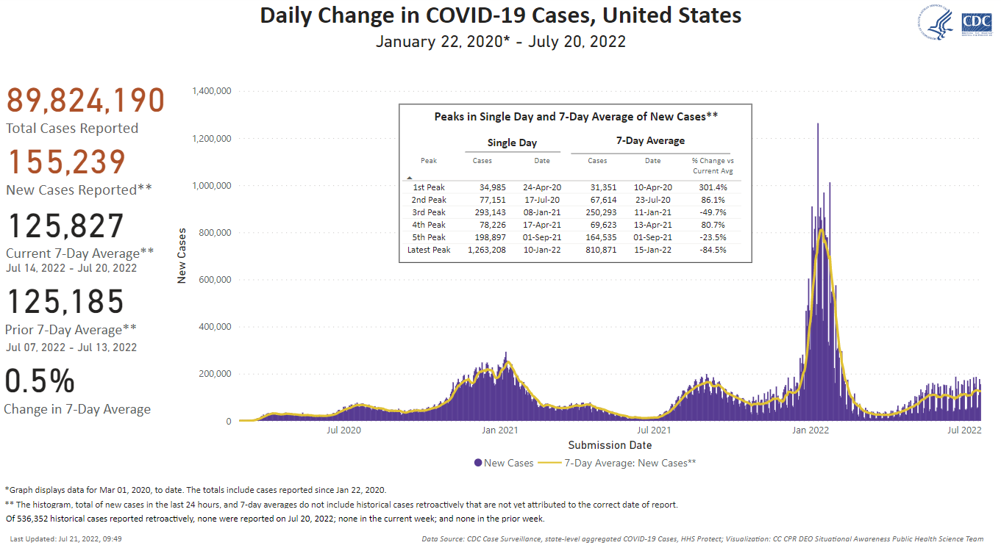

### COVID-19 Case Incidence (7-Day Cumulative) and Trend (Week-to-Week Percent Change)

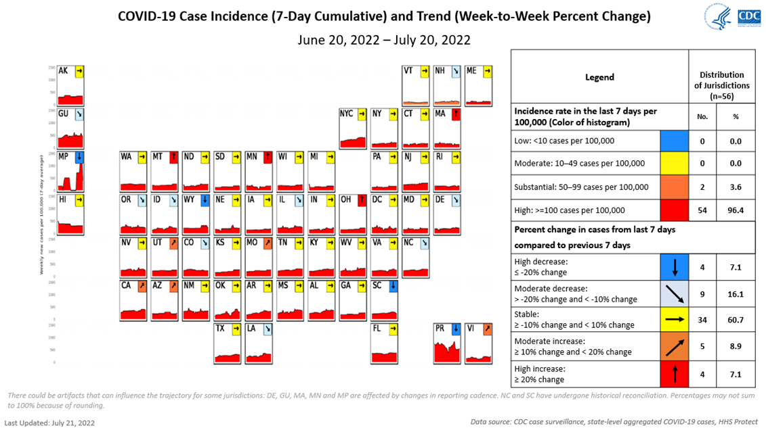

### New Admissions of Patients with Confirmed COVID-19, United States

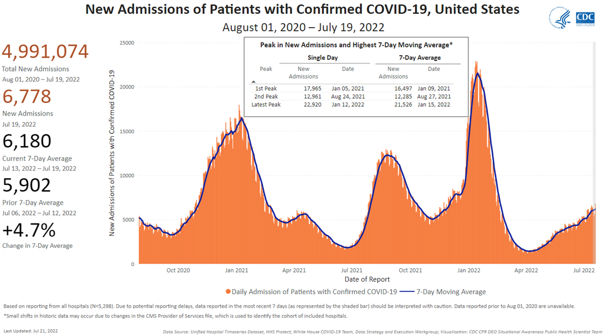

### Average 7-Day Admission of Patients with Confirmed COVID-19 per 100,000 Population and Percent Change

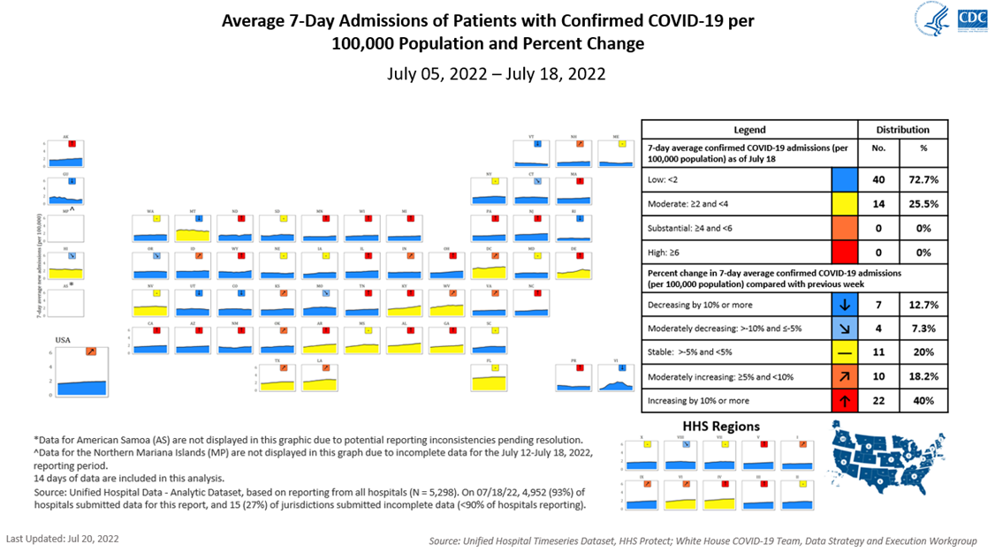

### Weekly Percentage of Emergency Department (ED) Visits of Patients Diagnosed with COVID-19

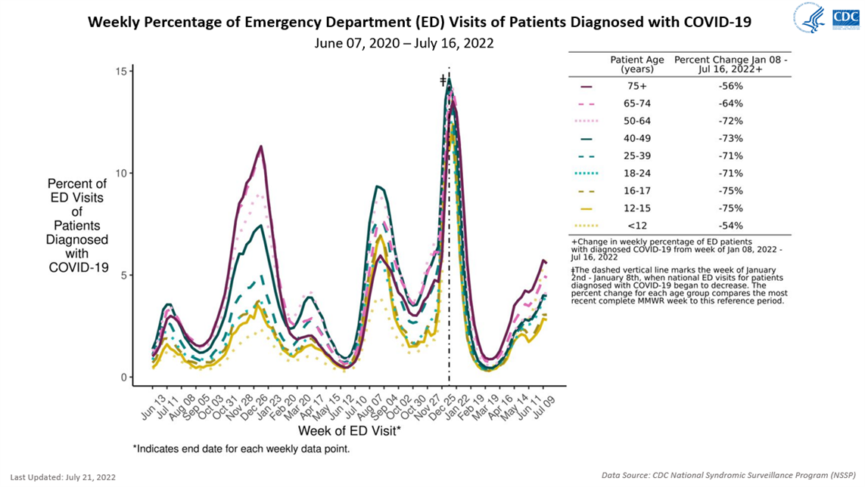

### Daily Change in COVID-19 Deaths, United States

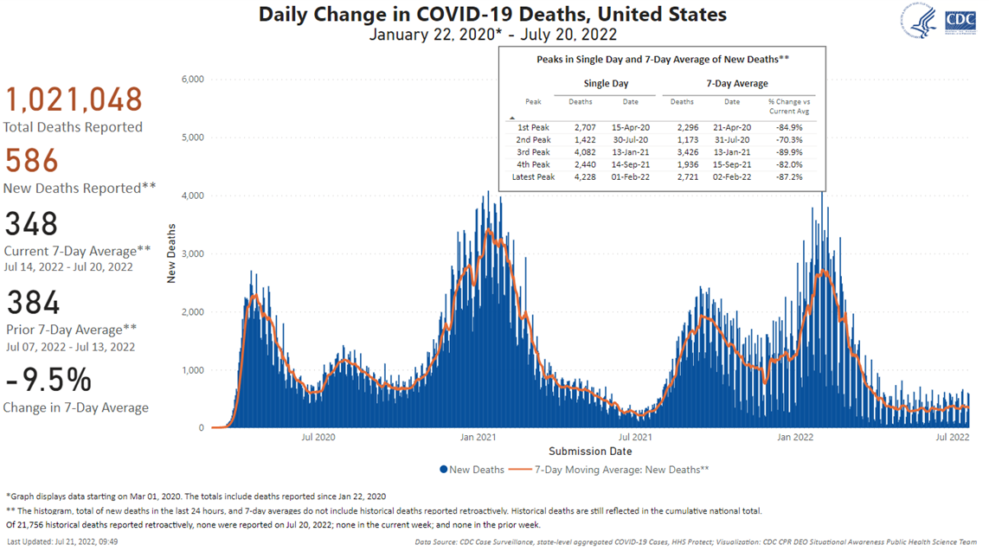

### Daily SARS-CoV-2 NAAT Percent Test Positivity and Test Volume, United States

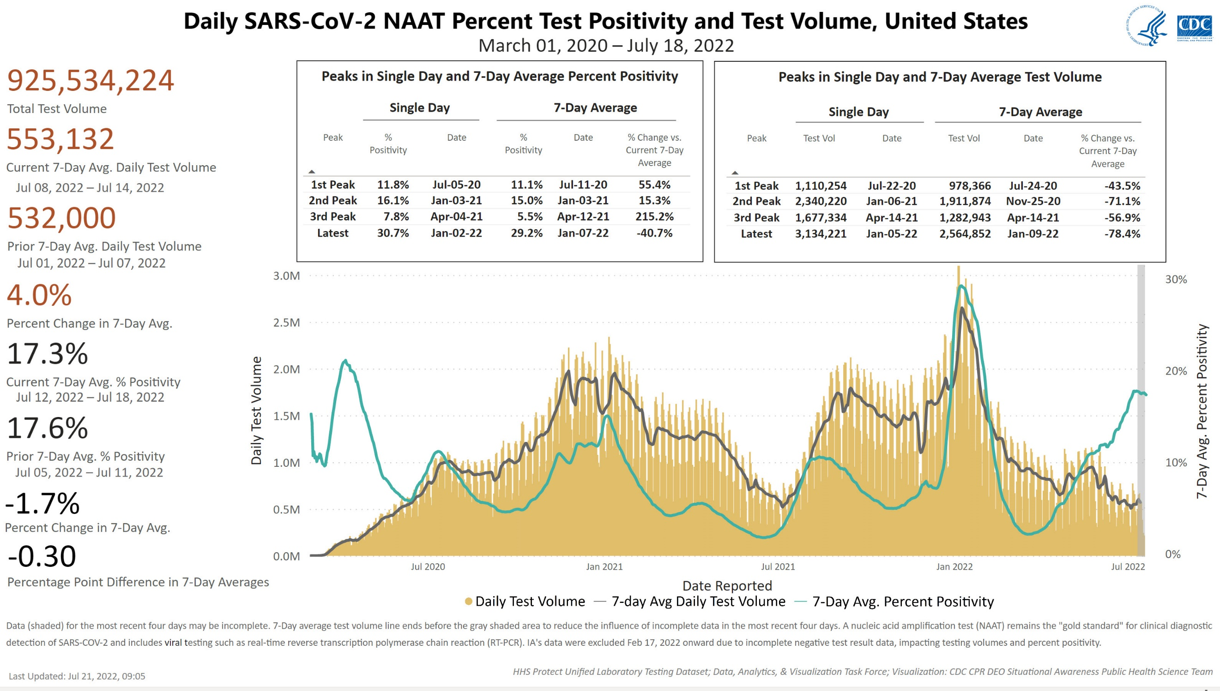

### Week-on-Week Changes

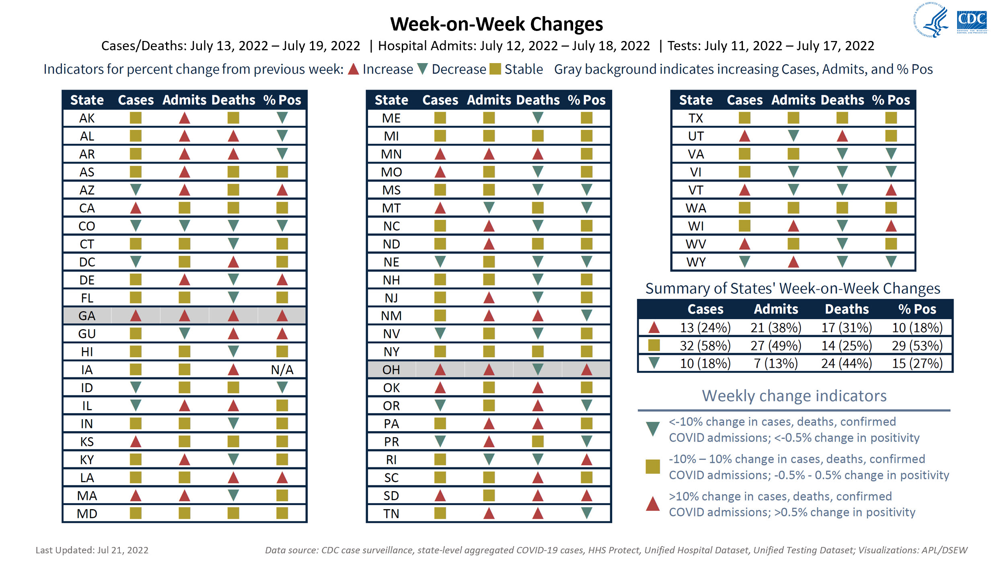

### Areas of Concern

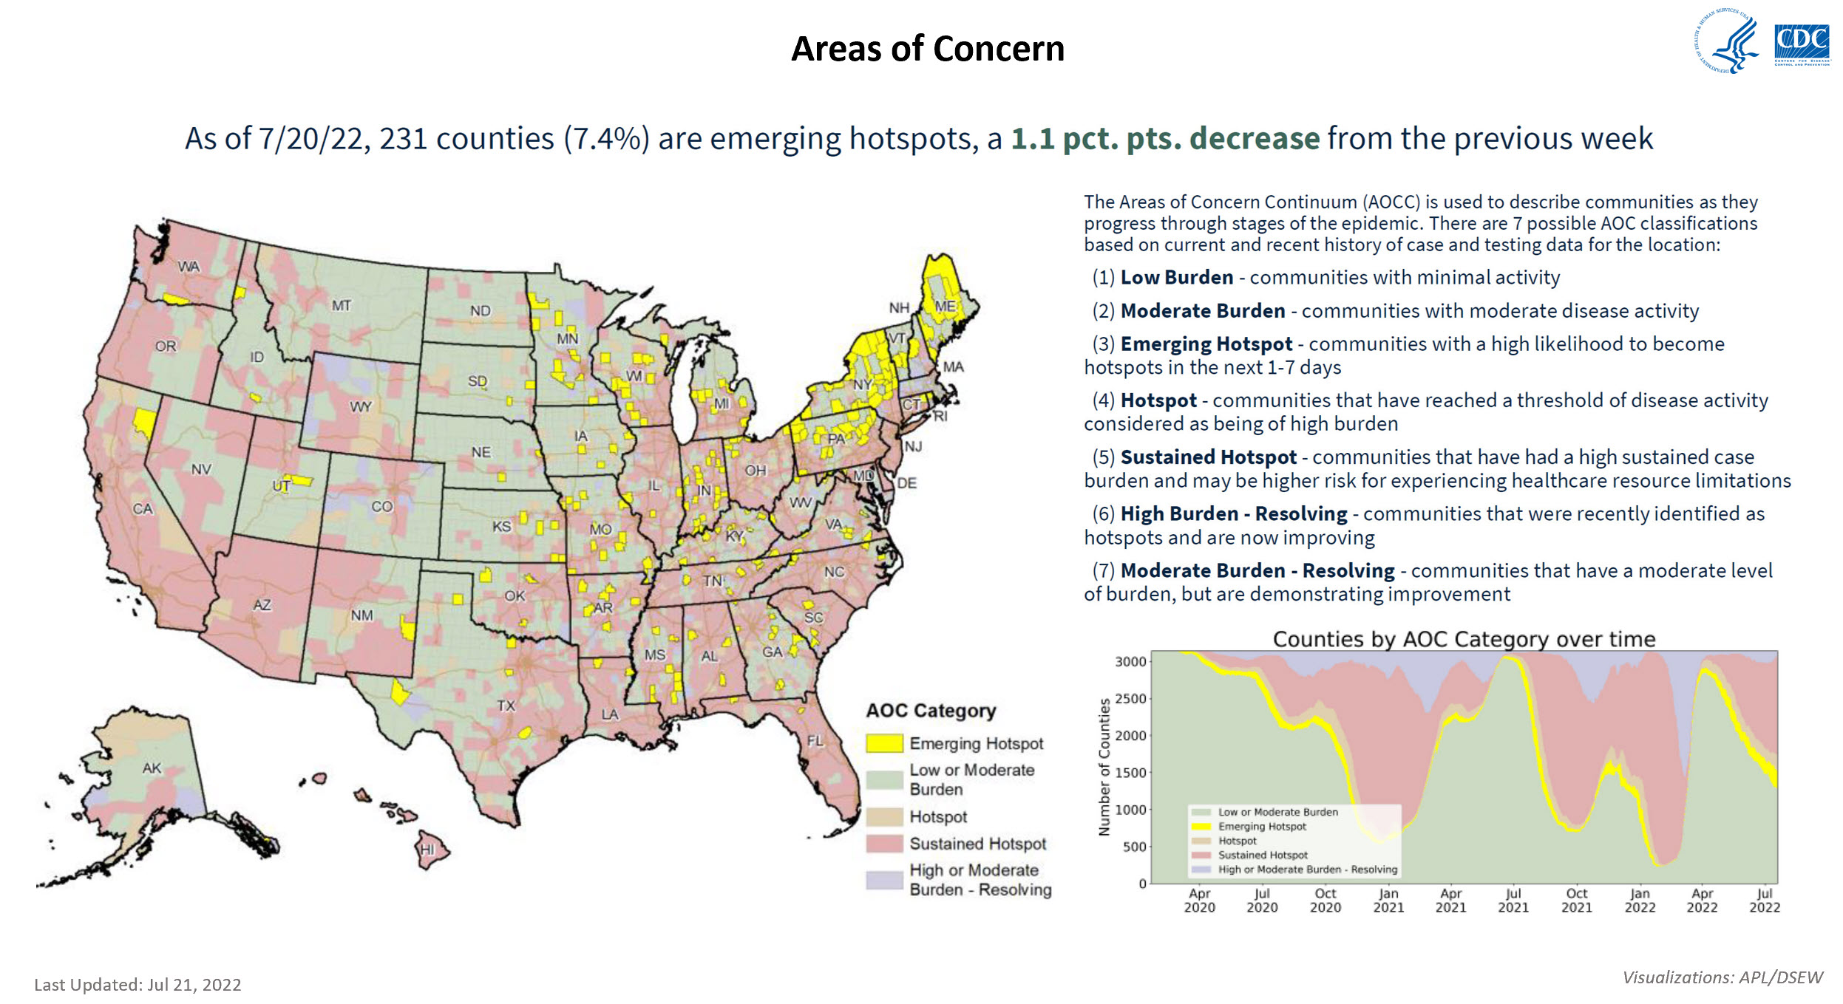

### COVID-19 Vaccine Distribution and Administration Reported to the CDC

| **COVID-19 Vaccine Distribution and Administration Reported to the CDC[7]** | | | | | | | | |
| --- | --- | --- | --- | --- | --- | --- | --- | --- |
| **State/Territory[8]** | **Doses Delivered** | | **Doses Administered** | | **People Receiving ≥1 Dose** | | **People Fully Vaccinated** | |
| **Total[9]** | **Rate/100K Population** | **Total9** | **Rate/100K Population** | **Total** | **% of Pop.** | **Total** | **% of Pop.** |
| **Alabama** | 10,351,240 | 211,113 | 6,463,818 | 131,829 | 3,031,113 | 63.5% | 2,538,510 | 51.8% |
| **Alaska** | 1,698,965 | 232,243 | 1,186,419 | 162,180 | 511,681 | 71.0% | 460,198 | 62.9% |
| **Arizona** | 15,983,420 | 219,591 | 12,727,134 | 174,854 | 5,562,819 | 74.7% | 4,559,893 | 62.6% |
| **Arkansas** | 6,728,980 | 222,976 | 4,373,349 | 144,918 | 2,012,057 | 67.6% | 1,664,434 | 55.2% |
| **California** | 97,189,655 | 245,974 | 78,558,967 | 198,822 | 32,675,987 | 83.4% | 28,857,182 | 73.0% |
| **Colorado** | 13,622,175 | 236,548 | 11,252,672 | 195,402 | 4,612,027 | 80.7% | 4,091,347 | 71.0% |
| **Connecticut** | 9,452,425 | 265,124 | 7,932,071 | 222,481 | 3,451,137 | 95.0% | 2,863,022 | 80.3% |
| **Delaware** | 2,564,295 | 263,338 | 1,898,246 | 194,939 | 838,308 | 84.6% | 685,035 | 70.3% |
| **Florida** | 51,488,705 | 239,731 | 38,822,718 | 180,758 | 17,381,059 | 80.4% | 14,565,785 | 67.8% |
| **Georgia** | 23,413,095 | 220,516 | 15,414,876 | 145,185 | 6,922,015 | 66.3% | 5,899,454 | 55.6% |
| **Hawaii** | 3,741,580 | 264,260 | 3,106,667 | 219,417 | 1,248,098 | 89.0% | 1,123,067 | 79.3% |
| **Idaho** | 3,765,990 | 210,736 | 2,599,811 | 145,479 | 1,103,863 | 62.6% | 1,001,141 | 56.0% |
| **Illinois** | 29,623,645 | 233,776 | 23,474,386 | 185,249 | 9,567,726 | 76.7% | 8,772,684 | 69.2% |
| **Indiana** | 14,603,780 | 216,924 | 10,166,418 | 151,011 | 4,225,353 | 62.8% | 3,807,779 | 56.6% |
| **Iowa** | 7,234,455 | 229,296 | 5,316,834 | 168,517 | 2,163,916 | 68.7% | 1,973,709 | 62.6% |
| **Kansas** | 6,596,115 | 226,413 | 4,718,365 | 161,959 | 2,079,753 | 73.5% | 1,829,395 | 62.8% |
| **Kentucky** | 9,625,975 | 215,458 | 6,747,393 | 151,027 | 2,949,097 | 67.0% | 2,593,203 | 58.0% |
| **Louisiana** | 8,840,350 | 190,164 | 6,453,138 | 138,813 | 2,877,826 | 61.7% | 2,514,436 | 54.1% |
| **Maine** | 3,738,750 | 278,137 | 3,003,998 | 223,477 | 1,235,492 | 92.4% | 1,085,513 | 80.8% |
| **Maryland** | 17,318,570 | 286,462 | 12,711,866 | 210,264 | 5,229,541 | 88.1% | 4,636,064 | 76.7% |
| **Massachusetts** | 18,236,110 | 264,579 | 15,543,791 | 225,517 | 6,866,304 | 95.0% | 5,530,303 | 80.2% |
| **Michigan** | 23,113,510 | 231,439 | 16,425,268 | 164,469 | 6,575,821 | 67.6% | 6,066,423 | 60.7% |
| **Minnesota** | 13,858,330 | 245,731 | 10,855,010 | 192,477 | 4,273,650 | 76.1% | 3,941,726 | 69.9% |
| **Mississippi** | 5,986,315 | 201,143 | 3,997,511 | 134,318 | 1,775,912 | 60.4% | 1,563,511 | 52.5% |
| **Missouri** | 12,534,405 | 204,229 | 9,297,738 | 151,492 | 4,121,702 | 67.1% | 3,491,007 | 56.9% |
| **Montana** | 2,148,795 | 201,052 | 1,647,783 | 154,174 | 703,456 | 66.0% | 614,006 | 57.4% |
| **Nebraska** | 4,324,310 | 223,547 | 3,320,203 | 171,639 | 1,360,115 | 71.1% | 1,241,910 | 64.2% |
| **Nevada** | 6,386,510 | 207,344 | 5,071,445 | 164,649 | 2,363,557 | 76.5% | 1,897,750 | 61.6% |
| **New Hampshire** | 3,856,300 | 283,612 | 2,683,255 | 197,340 | 1,238,035 | 90.0% | 976,877 | 71.8% |
| **New Jersey** | 23,731,455 | 267,180 | 17,871,786 | 201,209 | 7,891,964 | 91.8% | 6,809,772 | 76.7% |
| **New Mexico** | 4,828,045 | 230,255 | 4,125,432 | 196,746 | 1,795,650 | 89.6% | 1,515,040 | 72.3% |
| **New York** | 49,215,105 | 252,988 | 40,595,440 | 208,679 | 17,733,982 | 91.4% | 15,177,519 | 78.0% |
| **North Carolina** | 23,908,900 | 227,963 | 17,390,958 | 165,816 | 9,109,266 | 86.4% | 6,592,043 | 62.9% |
| **North Dakota** | 1,499,800 | 196,808 | 1,139,221 | 149,492 | 518,408 | 66.5% | 428,558 | 56.2% |
| **Ohio** | 25,038,055 | 214,200 | 18,531,065 | 158,533 | 7,530,524 | 64.0% | 6,892,130 | 59.0% |
| **Oklahoma** | 7,847,330 | 198,317 | 6,101,375 | 154,193 | 2,866,608 | 72.2% | 2,301,672 | 58.2% |
| **Oregon** | 10,995,485 | 260,696 | 8,163,981 | 193,563 | 3,322,705 | 78.9% | 2,969,746 | 70.4% |
| **Pennsylvania** | 33,221,725 | 259,504 | 24,075,849 | 188,063 | 11,114,096 | 86.7% | 8,945,611 | 69.9% |
| **Rhode Island** | 2,788,125 | 263,189 | 2,317,722 | 218,785 | 973,800 | 95.0% | 891,014 | 84.1% |
| **South Carolina** | 11,395,375 | 221,325 | 7,806,911 | 151,628 | 3,524,237 | 68.7% | 2,979,372 | 57.9% |
| **South Dakota** | 2,050,565 | 231,792 | 1,474,682 | 166,695 | 683,824 | 78.1% | 555,725 | 62.8% |
| **Tennessee** | 13,876,330 | 203,192 | 10,304,782 | 150,894 | 4,369,254 | 62.9% | 3,760,378 | 55.1% |
| **Texas** | 66,253,035 | 228,491 | 48,669,565 | 167,850 | 22,316,093 | 74.8% | 18,131,575 | 62.5% |
| **Utah** | 6,769,150 | 211,143 | 5,418,676 | 169,019 | 2,358,222 | 73.1% | 2,083,255 | 65.0% |
| **Vermont** | 1,955,890 | 313,449 | 1,479,555 | 237,112 | 602,888 | 95.0% | 512,793 | 82.2% |
| **Virginia** | 21,250,985 | 248,971 | 17,127,360 | 200,660 | 7,308,818 | 87.2% | 6,319,743 | 74.0% |
| **Washington** | 19,433,895 | 255,209 | 15,157,152 | 199,046 | 6,136,615 | 82.2% | 5,572,275 | 73.2% |
| **West Virginia** | 4,422,845 | 246,790 | 2,818,651 | 157,278 | 1,176,155 | 65.8% | 1,044,301 | 58.3% |
| **Wisconsin** | 12,628,245 | 216,889 | 10,744,653 | 184,539 | 4,240,150 | 72.7% | 3,858,313 | 66.3% |
| **Wyoming** | 1,061,485 | 183,407 | 768,328 | 132,754 | 339,816 | 58.9% | 298,235 | 51.5% |
| **American Samoa** | 123,210 | 259,981 | 112,281 | 236,920 | 45,303 | 95.0% | 42,027 | 88.7% |
| **CNMI** | 132,230 | 255,019 | 111,089 | 214,247 | 45,696 | 88.3% | 43,461 | 83.8% |
| **District of Columbia** | 2,076,105 | 294,170 | 1,620,078 | 229,554 | 775,774 | 95.0% | 542,489 | 76.9% |
| **FSM** | 177,900 | 173,866 | 146,799 | 143,470 | 71,436 | 70.5% | 61,351 | 60.0% |
| **Guam** | 338,560 | 200,939 | 369,539 | 219,325 | 154,963 | 92.2% | 140,783 | 83.6% |
| **Marshall Islands** | 110,680 | 142,370 | 77,628 | 99,855 | 37,749 | 48.6% | 30,673 | 39.5% |
| **Palau** | 46,890 | 217,769 | 49,145 | 228,242 | 20,350 | 95.0% | 18,287 | 84.9% |
| **Puerto Rico** | 7,830,450 | 245,185 | 7,411,597 | 232,070 | 3,043,036 | 95.0% | 2,674,541 | 83.7% |
| **US Virgin Islands** | 157,460 | 148,142 | 148,949 | 140,135 | 72,729 | 66.8% | 57,388 | 54.0% |
| **Unspecified[10]** | 918,005 | N/A | 3,596,402 | N/A | 2,066,504 | N/A | 854,760 | N/A |
| **USA[11]** | **784,110,065** | **236,171** | **601,497,801** | **181,169** | **261,204,035** | **78.7%** | **222,950,194** | **67.2%** |

N/A=Not available (no data)

Data as of Jul 20, 2022, 06:00 ET; Sources: Data Monitoring and Reporting Section, Vaccine Task Force; [COVID Tracker](https://covid.cdc.gov/covid-data-tracker/#vaccinations); US Census

### National Trends Compared to Winter 2021-21 Peak

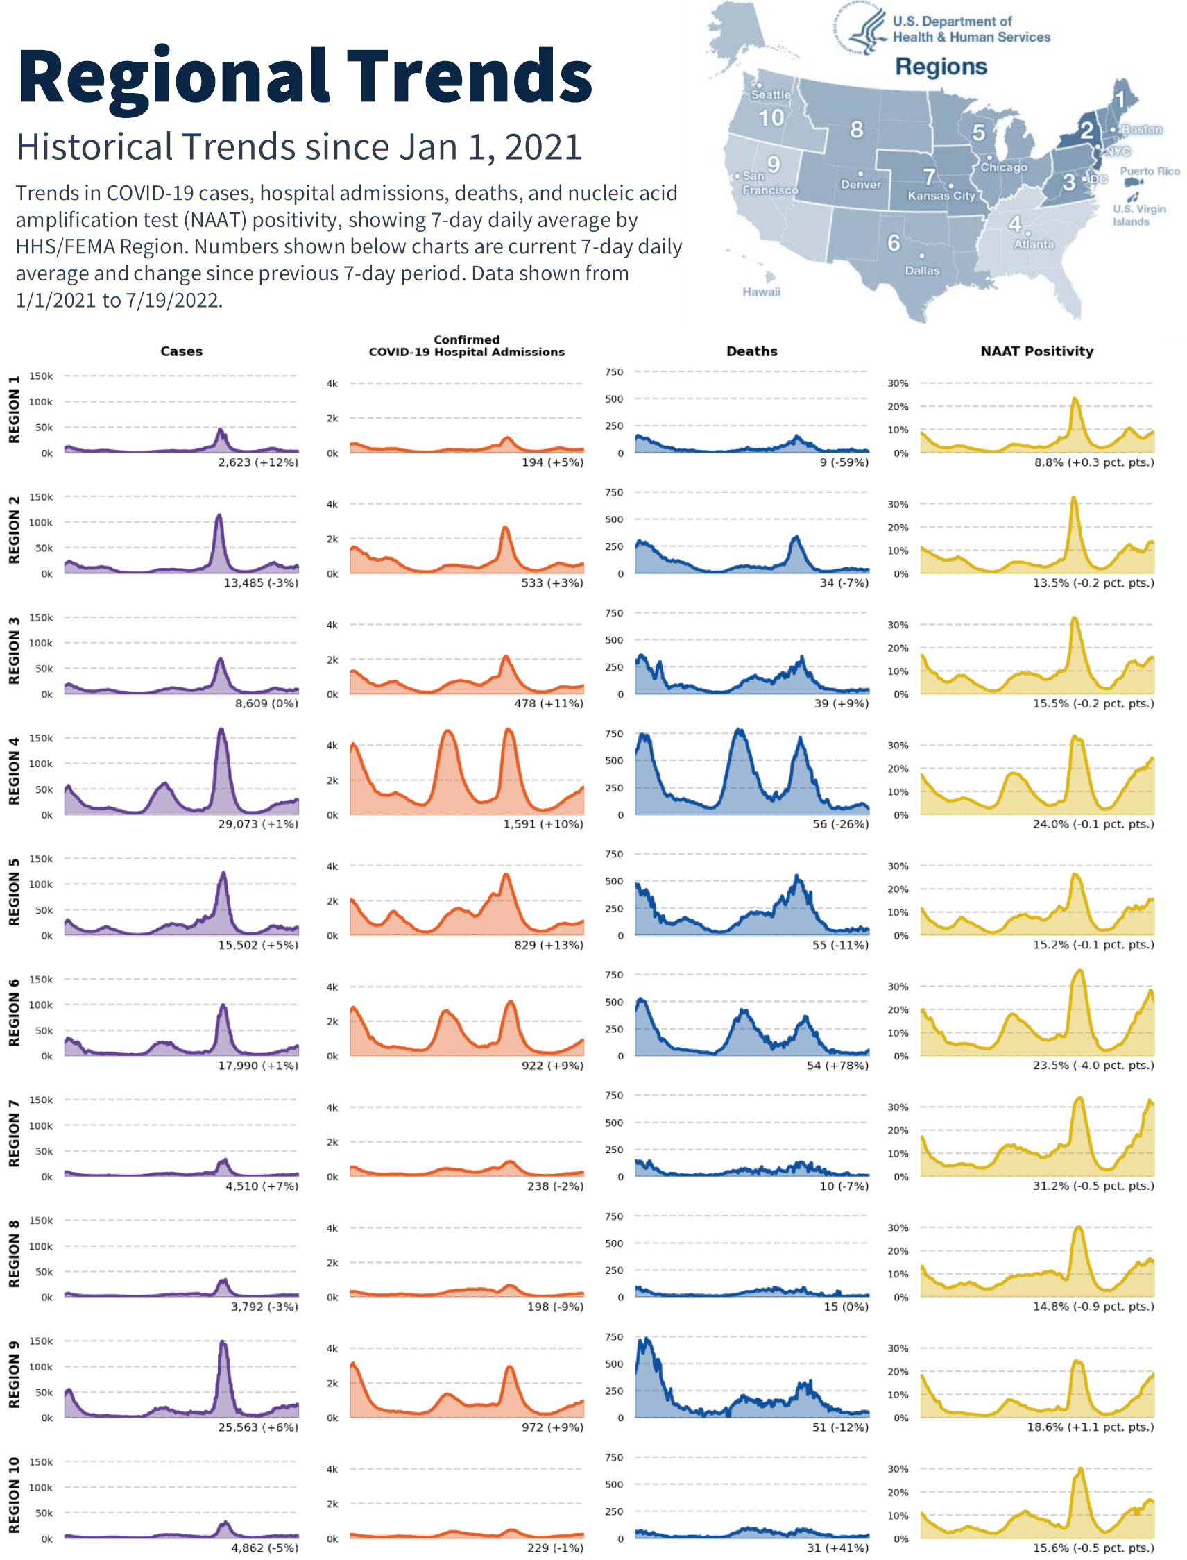

Last updated: Jul 21, 2022

1. Time period: Jan 22, 2020 - Jul 20, 2022; confirmed and probable cases and deaths. Number of jurisdictions reporting: 44 of 60. Aggregate case and death data are updated Mon – Sat. The total of new cases/deaths in the last 24 hours and 7-day averages do not include historical cases/deaths reported retroactively; historical cases/deaths are pending assignment to the appropriate dates. Of 536,352 historical cases reported retroactively, none were reported on Jul 20, 2022; none in the current week; and none in the prior week. Of 21,756 historical deaths reported retroactively, none were reported on Jul 20, 2022; none in the current week; and none in the prior week.
2. Time period: Aug 01, 2020 – Jul 19, 2022
3. Time period: Mar 01, 2020 - Jul 18, 2022; time period for test volume 7-day average and percent change: Jul 01, 2022 - Jul 14, 2022
4. Includes data for US States, DC, US Territories, federal entities, and pharmacies (see table on last page for breakdown)
5. Currently, only those 50 and older are eligible for 2nd additional doses.
6. Due to the inclusion of single dose and two-dose vaccines in Fully Vaccinated counts and because some doses lack information on dose type (First Dose, Fully Vaccinated, Additional Dose), the sum of the percentages may not equal 100%.
7. Green shading indicates higher rates of vaccine delivery or administration relative to other jurisdictions. Rates were calculated based on 2019 US Census data for US States, DC, and Puerto Rico; and based on 2020 US Census data for all other US territories.
8. CNMI = Commonwealth of the Northern Mariana Islands, FEMA = Federal Emergency Management Agency, FSM = Federated States of Micronesia, HRSA = Health Resources and Services Administration, RMI = Republic of Marshall Islands, and USVI = US Virgin Islands
9. Doses delivered to and administered in each jurisdiction include doses that were delivered to and administered by federal entities and retail pharmacies. Revisions to delivery data from providers may occur on occasion, resulting in a decrease in doses delivered.
10. Unspecified entities include doses delivered or administered by federal agencies outside the US or in unspecified jurisdictions.
11. The total doses allocated includes data from federal agencies and pharmacies. The total doses delivered or administered by a jurisdiction includes doses delivered to or administered by federal agencies. The US total also includes doses delivered to or administered by federal agencies where the jurisdiction was not specified.